A Project Report On

**“Computer Store Billing System”**

Submitted To

**MES. Garware College Of Commerce**

Savitribai Phule Pune University

In partial fulfilment of the degree of

**Bachelor of Business Administration-Computer Applications**



By

**Aishwarya Kadam (15432)**

**Priyanka Khandagale (15433)**

BBA-CA SemesterVI

Under the guidance of

**Mrs. Priyanka Jain**

Research Guide

MES Garware College of Commerce , Autonomous

Karve Road, Pune 411004

(2023-2024)



**MES GARWARE COLLEGE OF COMMERCE,** **AUTONOMOUS**

**PUNE-411004.**

**BACHELOR OF BUSINESS ADMINISTRATION – COMPUTER APPLICATION**

**CERTIFICATE**

This is to certify that **Miss. Aishwarya Kadam** Roll Number **15432** and

**Miss. Priyanka Khandagale** Roll Number **15433** University Exam Seat Number_____________ **Student** of **TY BBA-CA Semester-VI** has successfully completed the project work in specialization subject **Project based on Java Billing System** entitled as **“Computer Store Billing System”** a partial fulfilment of the degree of Bachelors of Business Administration Computer Application as per the syllabus of Savitribai Phule Pune University Year 2023-2024.

I further clarify that , the work has been carried out under my supervision.

Project Guide BBA Co-ordinator Principal

Internal Examine External Examine

**ACKNOWLEDGEMENT**

A successful project is the result of the hard work made and the guidance from a good mentor!!

I would like to express my deep gratitude towards my project guide Mrs Padma Nene Mam for her guidance, encouragement, and suggestions given throughout the project. This project built me up confidence, enhancing your skills and much more.

I would like to thank all the faculty 1members of the department for their constant support and encouragement.

**Index**

|  |  |
| --- | --- |
| 1 | Introduction |
| 2 | Objectives |
| 3 | Scope |
| 4 | Hardware and Software |
| 5 | System Design |
| 6 | Layout of the Website |
| 7 | Limitations |
| 8 | Conclusion |
| 9 | Bibliography |

|  |  |
| --- | --- |
| Project Title : | Computer Store Billing System |
| Name Of Group Members: | 15432 - Aishwarya Kadam  15433 - Priyanka Khandagale |
| Aim: | Develop a computer store billing system for efficient inventory management, smooth customer transactions, and accurate billing records. |
| Objective | 1. Inventory Management: Track, update, and organize inventory items. 2. Stock Monitoring: Real-time monitoring, alerts for low stock levels, and insightful reports. 3. Customer Billing System: User-friendly interface, customizable invoices, and secure payment processing. 4. Sales Reporting and Analysis: Generate sales reports, analyse trends, and track customer preferences. 5. User Management and Security: Multiple user roles, authentication, and audit trails. 6. Scalability and Flexibility: Design for future growth and integration with other systems. 7. User Training and Support: Comprehensive documentation, ongoing support, and feedback channels. |

**Introduction**

In today's rapidly evolving technological landscape, efficient management of inventory and streamlined customer transactions are crucial for the success of any retail business, including computer stores. The advent of computerized systems has revolutionized the way businesses operate, offering sophisticated solutions to address the challenges of inventory management and billing processes. In line with this, our project aims to develop a comprehensive computer store billing system that not only simplifies inventory management but also enhances the overall customer experience.

By leveraging cutting-edge technology, our system will provide robust features for inventory tracking, stock monitoring, customer billing, sales reporting, and user management. With a user-friendly interface and customizable functionalities, the system will empower store owners to efficiently manage their inventory, generate accurate invoices, and gain valuable insights into sales trends and customer preferences.

Moreover, prioritizing security and scalability, the system will implement stringent authentication mechanisms, audit trails, and user roles to safeguard sensitive data and facilitate seamless scalability as the business grows. Additionally, comprehensive user training materials and ongoing support services will ensure smooth adoption and continued success of the system.

Overall, our computer store billing system endeavours to be a reliable and indispensable tool for computer store owners, enabling them to optimize operations, enhance customer satisfaction, and drive business growth in today's competitive market environment.

**Scope:**

1. Inventory Management:

- Tracking and managing inventory of computers, peripherals, and accessories.

- Adding, updating, and removing items from the inventory.

- Categorizing and organizing inventory items for efficient management.

2. Stock Monitoring:

- Real-time monitoring of stock levels.

- Alerts for low stock levels to facilitate timely reordering.

- Generating reports on stock movement and trends for better inventory planning.

3. Customer Billing System:

- Creating and managing customer invoices.

- Customizing invoices to include item details, prices, and taxes.

- Integrating secure payment processing options for transactions.

4. Sales Reporting and Analysis:

- Generating sales reports, including total sales and revenue trends.

- Analysing sales data to identify top-selling items and customer preferences.

- Tracking sales performance over time and across different product categories.

5. User Management and Security:

- Implementing multiple user roles with varying levels of access.

- Providing authentication mechanisms to control access to sensitive functionalities.

- Logging user actions and maintaining audit trails for security and accountability.

6. Scalability and Flexibility:

- Designing the system to accommodate future growth and expansion.

- Allowing for integration with other systems or third-party services.

- Ensuring flexibility to adapt to changing business needs and requirements.

7. User Training and Support:

- Developing comprehensive user documentation and training materials.

- Providing ongoing support and maintenance services.

- Offering channels for user feedback and suggestions for continuous improvement.

The scope of the computer store billing system encompasses all aspects of managing inventory, facilitating customer transactions, analysing sales data, ensuring data security, and supporting users. By addressing these key areas, the system aims to streamline operations, enhance customer satisfaction, and drive business growth for the computer store.

**Hardware Specifications:**

Minimum Requirements:

Processor: Intel Core i3 or equivalent (or AMD Ryzen 3)

RAM: 4 GB

Storage: 500 GB hard drive (or equivalent solid-state drive)

Operating System: Windows 7 or later (64-bit recommended)

Display: Standard resolution monitor

Other: Keyboard, Mouse, Internet connection (optional for online updates)

**Software Specifications:**

Development Environment:

Java Development Kit (JDK) 11 or later

Apache NetBeans IDE 12 or later

Web Server:

Apache XAMPP (version compatible with chosen JDK)

Database (Optional):

MySQL (included with XAMPP) - for storing inventory data (if applicable)

**Advantages:**

1. Efficient Inventory Management: The system allows for real-time tracking of inventory levels, minimizing stockouts and overstocking.

2. Improved Customer Service: Streamlined billing processes and accurate invoicing enhance the overall customer experience.

3. Insightful Reporting: Sales reports and analytics provide valuable insights into purchasing trends and help in making informed business decisions.

4. Enhanced Security: Robust user authentication and access control mechanisms ensure the security of sensitive data.

5. Scalability: The system is designed to accommodate the growth of the business, making it suitable for expanding operations.

6. Time and Cost Savings: Automation of billing processes reduces manual errors and saves time, leading to cost efficiencies.

7. Customization: The system can be tailored to meet the specific needs of the computer store, offering flexibility in functionality and features.

**System limitations:**

1. Initial Cost: Implementing a computer store billing system may require a significant initial investment in software, hardware, and training.

2. Learning Curve: Users, especially those unfamiliar with technology, may require time and resources to adapt to the new system.

3. Technical Issues: Like any software, the system may encounter technical glitches or compatibility issues that require troubleshooting and maintenance.

4. Data Security Concerns: Storing sensitive customer and financial data electronically raises concerns about data breaches and cyberattacks.

5. Dependency on Technology: The system's reliance on technology means that any disruptions or failures in hardware or software could disrupt business operations.

6. Integration Challenges: Integrating the billing system with existing software or systems within the computer store may pose challenges and require additional effort.

7. Limited Customization: Off-the-shelf billing systems may have limitations in customization, potentially constraining the system's ability to meet unique business requirements.

**ERD**

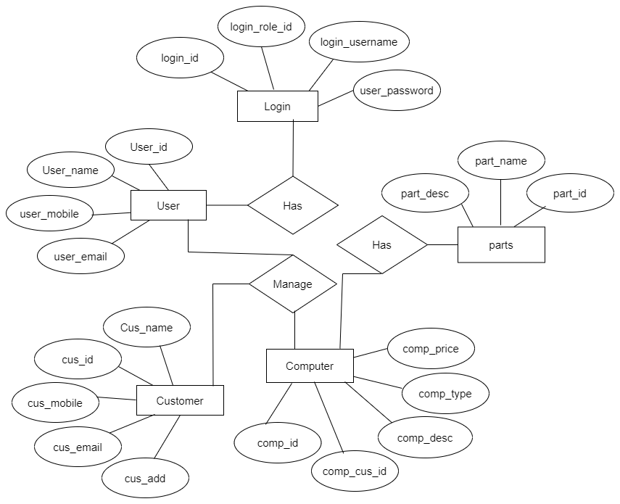

**DFD**

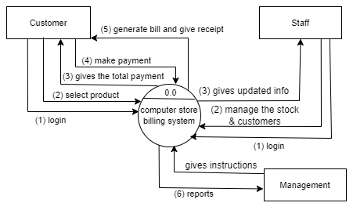

**Conclusion:**

In conclusion, the development of the computer store billing system represents a significant step towards modernizing and optimizing operations within the store. By implementing this system, the store aims to streamline inventory management, enhance customer satisfaction, and drive business growth. Through efficient tracking of inventory, seamless billing processes, and insightful sales reporting, the system empowers store owners to make informed decisions and adapt to changing market trends.

Furthermore, the emphasis on security, scalability, and user support ensures that the system meets the highest standards of reliability, adaptability, and usability. Leveraging hardware and software specifications, including the utilization of XAMPP server technology, the project sets a solid foundation for the successful implementation and operation of the billing system.

Overall, the computer store billing system not only enhances the efficiency and effectiveness of day-to-day operations but also lays the groundwork for future expansion and innovation within the store. By embracing technological advancements and best practices in business management, the project aims to position the store for long-term success in the competitive retail landscape.

**Bibliography:**

Java Development:

Flanagan, D. (2022). Head First Java (3rd ed.). O'Reilly Media. (A beginner-friendly introduction to Java)

Althoff, P., Farley, D., & Moore, J. (2009). Java Persistence with Hibernate (2nd ed.). Manning Publications. (For developers using Hibernate for database persistence)

Oracle Corporation. (n.d.). Java Tutorial. (Official Java tutorials from Oracle)

NetBeans IDE:

NetBeans IDE Documentation. [https://netbeans.apache.org/kb/docs/](https://netbeans.apache.org/kb/docs/) (Official NetBeans documentation for various functionalities)

NetBeans IDE Tutorials. [invalid URL removed] (Step-by-step tutorials for using NetBeans for Java development)

XAMPP and Database Management:

Apache Friends. (n.d.). XAMPP Documentation. [https://www.apachefriends.org/docs/](https://www.apachefriends.org/docs/) (Official XAMPP documentation for installation, configuration, and troubleshooting)

MySQL Tutorial. [invalid URL removed] (Interactive tutorial for learning basic MySQL concepts)

Vogels, W. (2010). High Performance MySQL: Optimization, Backup, Replication, and More (3rd ed.). O'Reilly Media. (For advanced database administration with MySQL)

Computer Store Billing Systems:

Alexander, M. (2019). Designing and Implementing a Point-of-Sale System for a Retail Store. (Discusses designing a point-of-sale system for a retail store)